**Project Design Phase-II**

**Data Flow Diagram & User Stories**

|  |  |
| --- | --- |
| Date | 27 June 2025 |
| Team ID | LTVIP2025TMID36584 |
| Project Name | cleantech: transforming waste management with transfer learning |
| Maximum Marks | 4 Marks |

**Data Flow Diagrams:**

A Data Flow Diagram (DFD) is a traditional visual representation of the information flows within a system. A neat and clear DFD can depict the right amount of the system requirement graphically. It shows how data enters and leaves the system, what changes the information, and where data is stored.

**Flow:**

* A user uploads an image of waste via the web application.
* The Flask backend receives and preprocesses the uploaded image.
* The preprocessed image is then sent to the AI model for classification.
* The AI model, which is a trained Convolutional Neural Network (CNN) based on MobileNetV2, predicts the waste category (Biodegradable, Recyclable, or Trash).
* The classification result is returned to the frontend and displayed to the user along with the uploaded image.
* Prediction results are also recorded in terminal logs.

**Data diagram:**

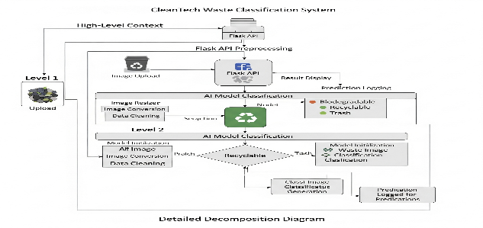

**User Stories:**

| **User Type** | **Functional Requirement (Epic)** | **User Story Number** | **User Story / Task** | **Acceptance criteria** | **Priority** | **Release** |
| --- | --- | --- | --- | --- | --- | --- |
| Customer (Web user) | Waste Classification | USN-1 | As a user, I can upload an image of waste. | The image is successfully uploaded to the system. | High | Sprint-1 |
| Customer (Web user) | Waste Classification | USN-2 | As a user, I can receive an accurate classification of the waste image (Biodegradable, Recyclable, or Trash). | The system displays the correct classification label. | High | Sprint-1 |
| Customer (Web user) | Waste Classification | USN-3 | As a user, I can see the uploaded image along with its classification. | The uploaded image is visible with the classification result. | Low | Sprint-1 |
| Administrator | System Monitoring | USN-4 | As an administrator, I can view terminal logs showing classification predictions. | Terminal logs display accurate prediction details. | Medium | Sprint-1 |
|  |  |  |  |  |  |  |
|  |  |  |  |  |  |  |
|  |  |  |  |  |  |  |